

YEAR: 10
SUBJECT: SCIENCE

Name: __________________________________________________

Date: __________________________ Form: __________________

TEST: Physics
TIME: 40 minutes
TOTAL MARKS: 35 marks

FORMULAE:
Speed: v = d / t
Acceleration: a = (v-u) / t
Momentum: p = m x v
Work: W = F x d

Question 1: (3 marks)
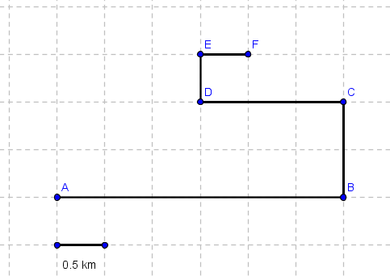

The above image is a dirt bike track. Using the scale, detail the distance from:
- B to A: 3km (0.5 marks for correct answer, 0.5 marks for correct unit)
- D to B: 2.5km (0.5 marks for correct answer, 0.5 marks for correct unit)
- F to A: 6.5km (0.5 marks for correct answer, 0.5 marks for correct unit)

Question 2: (6 marks)

- If you travel 400 metres in 50 seconds, what is your speed?
V = d / t → 400 / 50 → 8 m/s (1 mark for equation, 1 for correct answer, 1 for correct unit)
- If you are travelling at 60 km/h, how long will it take you to travel 800 kilometres?
t = d / v → 800 / 60 → 13.333 hours (13 hours, 20 minutes) (1 mark for equation, 1 for correct answer, 1 for correct unit)
Question 3: (6 marks)

- Adam is test-driving his new car at 6 m/s. Adam applies force to the throttle, and within 4 seconds, he reaches 35 m/s. How much does Adams vehicle accelerate?
a = (v-u) / t → (35-6) / 4 →7.25m/s2 (1 mark for equation, 1 for correct answer, 1 for correct unit)
- Adams sister Jessica watches Adam zoom past her, and realises that she is also speeding. Jessica decides to slow down from 30 m/s to a comfortable 15 m/s, which takes her 2 seconds. How much has Jessica’s vehicle decelerated?
a = (v-u) / t → (15-30) / 2 → -7.5 m/s2 (1 mark for equation, 1 for correct answer, 1 for correct unit)

Question 4: (6 marks)

List each of Newton’s laws, and provide an example of where you would see this law in practice during your daily life:
Newton’s first law: An object remains at rest or in constant motion in a straight line unless acted on by a net unbalanced force. (1 mark for a fair attempt, 2 marks for law stated in full)
Newton’s second law: The acceleration of an object is directly related to the magnitude and direction of the force acting on the object, and inversely related to the mass of the object: F = m x a (1 mark for the written law, one mark for providing the equation)
Newton’s third law: For every action, there is an equal and opposite reaction on the other object. (1 mark for a fair attempt, 2 marks for law stated in full)

Question 5: (6 marks)

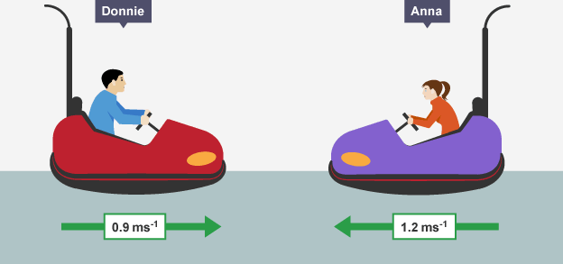

Donnie’s Mass: 700 kg Anna’s Mass: 660kg

- What is Donnie’s momentum?
P = m x v → 700 x 0.9 = 630 kg m/s to the right (1 mark for working out, 1 for correct unit and direction)

- What is Anna’s momentum?
P = m x v →660 x 1.2 = 792 kg m/s to the left (1 mark for working out, 1 for correct unit and direction)

- Once Donnie and Anna collide, detail the final momentum and the direction.
792 – 630 = 162 kg m/s to the left. (1 mark for working, 1 mark for unit and direction)

Question 6: (4 marks)


Above is a picture of Robert. On Friday, Robert’s boss asked him to complete a report due by Monday. Not only did Robert not do the report, he also came to work 10 minutes late on Monday. Robert lost his job, and was asked to pack up immediately.
Robert had two options; either pack all his items into one large box, or to pack his items into three smaller boxes. The distance from his office to his car was 600 metres. The large box had a force of 80 N, whilst the smaller boxes had a force of 25 N.

a) How much work would Robert perform carrying the first box?
W = f x d → 80 x 600 = 48000J or 48 kJ (1 mark for working, 1 mark for correct answer with unit)

b) How much work would Robert perform carrying the three smaller boxes?
W = f x d → 25 x 600 = 15000 x 3 = 45000J or 45 kJ ( 1 mark for working, 1 mark for correct answer with unit)

Question 7: (4 marks)

a) State the law of conservation of energy:
The law of conservation of energy states that energy cannot be created or destroyed, only transferred. ( 1 mark for created or destroyed, 1 mark for transferred)
b) List two forms of “waste energy”
Heat, light, sound ( 1 mark each example)

END OF TEST – PLEASE CHECK YOUR WORK

